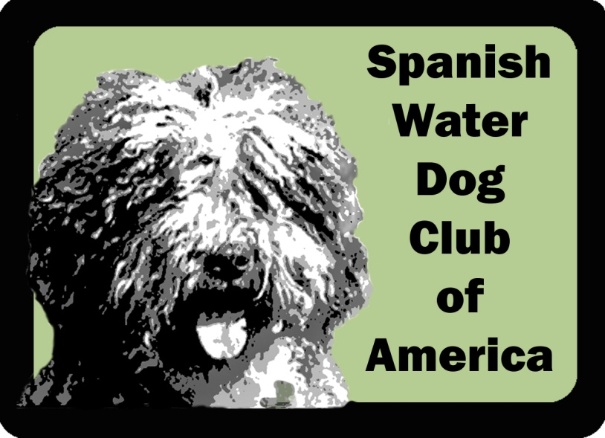
New Membership 2019

Thank you for your interest in the Spanish Water Dog Club of America, Inc. Thank you for your interest in the Spanish Water Dog Club of America, Inc. We are a group of committed owners and fanciers looking to promote, maintain, and further this wonderful breed. The Spanish Water Dog Club of America offers several types of membership options for you. Please see below to decide on the membership type that is most appropriate for your needs. Once you have decided upon your membership type, please select the appropriate amount and complete the remainder of this form.

1. Please provide the following information.
Name

Occupation:

Additional Name
(if Household Membership):

Occupation:

Address

City

State

Zip

Country

Phone

Email

Please provide the following information about your dog(s):

Dog's Nickname

Kennel Name

Age

Title(s)

Activities
(herding, dock jumping,
conformation, agility,
rally, etc.)

Dog's Nickname

Kennel Name

Age

Title(s)

Activities
(herding, dock jumping,
conformation, agility,
rally, etc.)

Dog's Nickname

Kennel Name

Age

Title(s)

Activities
(herding, dock jumping,
conformation, agility,
rally, etc.)

Dog's Nickname

Kennel Name

Age

Title(s)

Activities
(herding, dock jumping,
conformation, agility,
rally, etc.)

Dog's Nickname

Kennel Name

Age

Title(s)

Activities
(herding, dock jumping,
conformation, agility,
rally, etc.)

Dog's Nickname

Kennel Name

Age

Title(s)

Activities
(herding, dock jumping, conformation, agility, rally, etc.)

2. Membership categories:

Individual Membership: One-person membership with full voting privileges. Applicant must be a US resident and over the age of 18.-$35 US dollars

Household Membership: Two-person membership with full voting privileges living within the same household. Applicants must be US residents and over the age of 18.-$50 US dollars

Foreign Membership: One-person membership without voting privileges. Applicant resides outside the USA and is over the age of 18.-$30 US dollars--We recommend that you make your payment via the website using the Paypal button

Junior Membership: One-person membership without voting privileges. Applicant must be a US resident and under the age of 18.-$20 US dollars

Honorary Membership: An individual who has made significant contributions to the Sport, Breed or the Club; honorary members pay no dues and are not eligible to vote, but can maintain an individual or household membership if they pay dues.

2b. Payment :just mail your renewal form and check, via the US Postal Service, to

SWD Club of America
c/o Nancy P. Valley
308 Granite Road
Guilford, CT 06437

3. Who is endorsing your membership to the SWDCA Club? (The endorsement of at least one member in good standing is required.)

Member name
Member name

I do not know any current SWDCA member. Please have a board member contact me.

4. Your SWD Club of America is always in need of volunteers for its committees. Would you be interested in volunteering in any of the following? (You can mark one or more.)
Health and Wellness
Rescue
Breed Education
Specialty Planning
Mentorship
Other (specify what your interest is): _______________________________________________

5. Do you have skills or abilities that could help the Club in some way (e.g., website development, publishing, veterinarian expertise, training, grooming, etc.) and that you would like to share with us?

6. Please provide us some background information regarding your dog(s), your history, and experience with dogs.

7. From time to time, members ask for the contact information of another member(s) for to be able to get in touch with them directly and off list. (Contact information provided to the member is not to be shared with any third parties.) Do you approve having the Corresponding Secretary or Treasurer of the SWDCA Board provide your contact information to another member, if requested
If yes, what type of information can we provide (please select all that apply):
Name
Address
Phone
Email

8. Do you give permission for your contact information to be published in a member directory only for distribution among members? The directory is to be used for Club business only and not for solicitation purposes by any member except by the express authorization of that(those) member(s).
Yes No

Signature and Date:
Second Signature (if Household Membership):
9. Electronic communication notice*:
I/We hereby consent to the Spanish Water Dog Club of America, Inc., sending me/us electronic notifications of the annual Club meeting and any other special meetings as noted in the Club's bylaws; the annual Club meeting minutes; membership renewal and dues notices; and newsletters. By providing this authorization, which is revocable, I/we release the Club from any liability should the notification be received late or not received due to circumstances beyond the Club’s control.
Yes No
Signature* and Date*:
Second Signature (if Household Membership):
10. Membership agreement*:
I/We hereby submit my/our application for membership in the Spanish Water Dog Club of America, Inc. I/We, by my/our signature(s) agree to abide by the rules of the American Kennel Club and the Constitution, By-laws and Code of Ethics of the Spanish Water Dog Club of America, Inc.; promote the best interests of the Spanish Water Dog Club of America in accordance with these rules and bylaws; conscientiously place the good of the Spanish Water Dog and those dogs within my/our care above all other considerations. I/We further agree to become known to the Club at large through support of Club activities and events and through services rendered to the Club and to the Spanish Water Dog.

Signature* and Date*:
Second Signature (if Household Membership):

