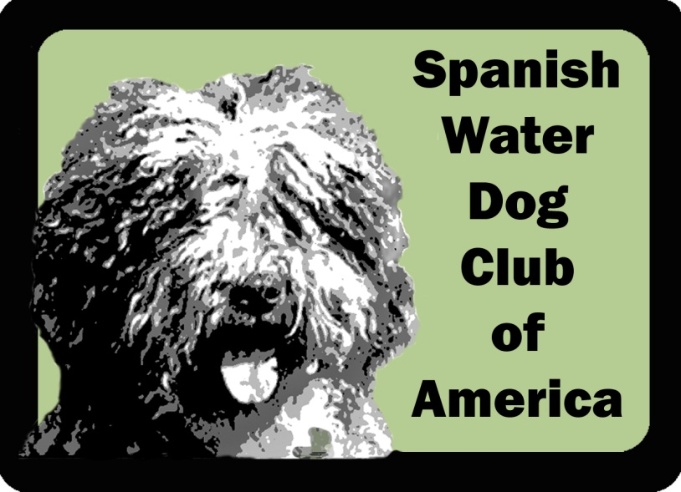
Membership Renewal

Membership Type: Individual Household Foreign Junior Honorary
Name(s): Occupation:
Email(s): Phone(s):
Address:
City: State: Zip: Country:

Our primary club communication is via email. To allow better member interaction, we list member contact information (name, email, phone, address) in a member‐only access directory. If you wish to exclude your street or phone number from this directory, please indicate here: Exclude Street Exclude Phone

Current activities you are engaged in or considering doing with your dog(s):
Agility Barn Hunt CAT/FastCAT Conformation Disc Dog Dock Diving Herding Obedience Rally Scent/Nose Work Therapy Tracking Trick Dog
Other ____________

Your SWD Club of America is always in need of volunteers for its committees. Would you be interested in volunteering in any of the following? (You can mark one or more.)
Breed Education Health and Wellness Judges Education Membership Mentorship Newsletter Online Learning Rescue
Social Media/PR Specialty Planning Sunshine Versatility
Other ______________

Do you have skills or abilities that could help the Club in some way that you would like to share with us?
Grooming Legal Marketing Publishing Training
Veterinarian Website Development
Other ____________
Please tell us about your Spanish Water Dogs:

 | Dog 1 | Dog 2
Call Name
Registered Name
AKC Number
Titles
Sex and Birth Date
Source/Kennel

 | Dog 3 | Dog 4
Call Name
Registered Name
AKC Number
Titles
Sex and Birth Date
Source/Kennel

 | Dog 5 | Dog 6*
Call Name
Registered Name
AKC Number
Titles
Sex and Birth Date
Source/Kennel
*list any additional dogs after signatures

If you would like to bring insights or suggestions to the attention of the Board of Directors, please feel free to include them here.
Electronic communication notice*:
I/We hereby consent to the Spanish Water Dog Club of America, Inc., sending me/us electronic notifications of the annual Club meeting and any other special meetings as noted in the Club's bylaws; the annual Club meeting minutes; membership renewal and dues notices; and newsletters. By providing this authorization, which is revocable, I/we release the Club from any liability should the notification be received late or not received due to circumstances beyond the Club’s control.

Signature: Date:
Household Member’s Signature: Date:

Membership agreement*:

I/We hereby submit my/our application for membership in the Spanish Water Dog Club of America, Inc. I/We, by my/our signature(s) agree to abide by the rules of the American Kennel Club and the Constitution, By-laws and Code of Ethics of the Spanish Water Dog Club of America, Inc.; promote the best interests of the Spanish Water Dog Club of America in accordance with these rules and bylaws; conscientiously place the good of the Spanish Water Dog and those dogs within my/our care above all other considerations. I/We further agree to become known to the Club at large through support of Club activities and events and through services rendered to the Club and to the Spanish Water Dog.

Signature: Date:
Household Member’s Signature: Date:

List any additional dogs below:

