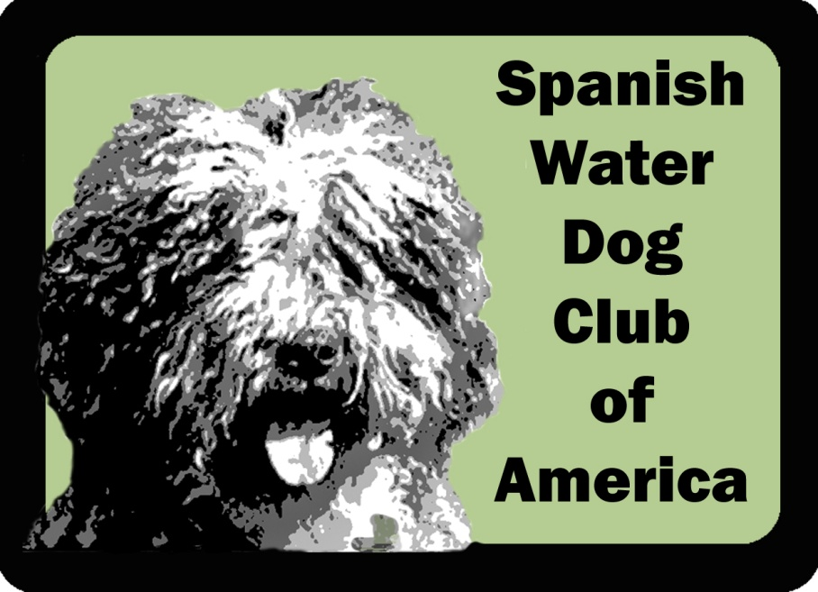

SWDCA BREEDER AND STUD DOG REFERRAL LIST

AGREEMENT AND APPLICATION
Members of the Spanish Water Dog Club of America (SWDCA) who are breeders and stud dog owners who wish to participate in the SWDCA's Breeder and Stud Dog Referral List must read, fill out the required information, sign, and submit the following agreement to the SWDCA.

Yearly dues to participate is $50 US per annum, with the year ending December 31 of each year.

Listings will include name, address, and current contact information, along with designation of ‘Stud Dog Only” if applicable. It is the listee’s responsibility to keep information updated by notifying the SWDCA Corresponding Secretary of any changes.

Breeder and Stud Dog Referral List Agreement

- I will abide by the SWDCA Code of Ethics
- I will submit all health testing results, including those tests that do not receive a passing score or results that are not normal, for currently recommended tests listed on the CHIC website to the Orthopedic Foundation for Animals (OFA) for publication on their website.
- I will deal honestly with inquirers and help educate prospective owners and fanciers about the Spanish Water Dog.
- I will provide prospective owners, prior to a transfer or sale, copies of all health test results on the sire and the dam of puppies or dogs I have for sale or placement. If one or both of the parent dogs do not have certain of these ratings, the prospective owners will be so advised. If either parent is known to be affected with a health problem, including but not limited to Hip Dysplasia, Hypothyroidism, Hair Loss or PRA, or is a PRA carrier the prospective owners will be advised. If an adult dog is being sold or transferred, the same information will be provided for that dog as well as its parents.
- I will deal honestly with the owner of a stud dog servicing my brood bitch or the owner of a brood bitch being serviced by my stud dog and will provide all health information as stated in Item 4 of this Code.
- I will provide a written contract or agreement for the sale or placement of each puppy/dog and will include copies of all pertinent health information with said contract or agreement. This is for my own protection as well as the puppy/dog involved and the new owners.
- I will do my best to adequately query prospective owners prior to the sale or placement of a puppy/dog. I will do so to insure that every puppy/dog will have a life with dignity, freedom from fear and pain, proper care, socialization, training and grooming and a devoted owner.
- I will be certain my brood bitch receives proper care, especially during pregnancy and whelping, and that my stud dog's good health is maintained at all times.
- I will ensure all puppies receive proper veterinary care from whelping until placement with a permanent owner.
- I will provide my puppies with as much human contact as possible to ensure proper socialization to people.
- I will be available to provide advice, guidance and information to the owners of my puppy/dog throughout the lifetime of the animal.
- I will accept the return of any puppy/dog I have bred and sold or placed, or if not feasible, I will assist both logistically and/or financially in the re home of the puppy/dog. If the puppy/dog comes into a rescue and relocation program, I will reclaim the puppy/dog or accept full financial responsibility for its care
- I will remain current on all health issues involving the breed.
- All of the litters which I have bred, or co-bred will be registered with the American Kennel Club.
- I will provide membership information to anyone who obtains a puppy/dog from me.
- I have read and am familiar with the AKC Breed Standard for the Spanish Water Dog and will do my best to breed dogs which fit that description.
- I understand I will be removed immediately from the Breeder and Stud Dog Referral List if suspended by the AKC or SWDCA for any reason. Upon reinstatement by the AKC or SWDCA, I can reapply for inclusion on the next Breeder and Stud Dog Referral List
- I understand that if the SWDCA receives a formal complaint about my actions as a participant on the Breeder and Stud Dog Referral List, a formal inquiry may result. If I am found in violation of any part of this agreement, I may be removed from the list for a specified period of time, in accordance with Article VI of the SWDCA's Bylaws.
- I agree that under no circumstances will I knowingly sell a puppy/dog to a pet store or broker. I agree with the above points and wish to be included on the SWDCA's Breeder and Stud Dog Referral List. I am a member in good standing of the SWDCA.

The SWDCA recommends that you retain a copy of this agreement and the signed application for each year you participate.

Breeder and Stud Dog Referral List Application

I*, |  | the undersigned,
 | (your full name: as it is to appear on the website listing)
am the breeder and/or authorized representative of the kennel identified below, and hereby certify and agree, both individually and, if applicable, on behalf of the kennel, that I have read, understood and agree to the recited terms and requirements listed in the SWDCA Breeder and Stud Dog Referral List Agreement and request that my kennel be listed on the on the SWD Club of America's website.

Signature*:

Date*:

Kennel Name*:

Breeder | Yes | No | Stud Dog | Yes | No
(Circle all that apply)*

Any planned litters for this year? | Winter | Spring | Summer | Fall
(Circle all that apply)*

Address*:

State*:

Zip*:

Country*:

Contact phone number*:

Email*:

Website:

All fields marked with an * are required.

The SWDCA recommends that you retain a copy of the most current agreement and the signed application for each year you participate.

Instructions: Fill out the application form and mail it along with a $50 check in US dollars (payable to Spanish Water Dog Club of America, Inc.) to the following address:

SWDCA Club, Inc. Treasurer
c/o Nancy P. Valley
308 Granite Rd. Guilford, CT 06437
USA

A note to foreign members, Paypal is the easiest way to make a payment in US dollars. You can find a Paypal button on the club website. Be sure to make a notation that the payment is for the breeder/stud listing.

